**SimpliLearn Capstone**

**Project Details**

# **Introduction**

This document aims to elaborate the features, database model, application architecture and flow, automation testing, DevOps, technology used for the development and the sprint planning of the project named Foodbox.

## **Product Capabilities**

The Foodbox system demonstrates a dynamic and responsive online food delivery web application for ordering food items of different cuisines from a restaurant. It has two main functionalities:

1. Allow administrator to manage master data such as food categories, food items and offers, and view order and user reports.
2. Allow guest or user to view food categories and food items details, search, filter and sort food items, and add food items to cart. Guest must sign up and login as user to perform checkout and payment.

### **Admin Portal**

The web pages of administrator consist of:

* A login page for administrator to sign-in to manage master data and view reports.
* Page to view a table list of categories created by the logged-in administrator. Administrator can delete category by selecting the trash button displayed on each table row. The category can be enabled or disabled by toggling the switch button.
* Page to create category by filling up the category form. Administrator can also upload category image file in this page.
* Page to update category details and change category image.
* Page to view a table list of foods created by the logged-in administrator. Administrator can delete food by selecting the trash button displayed on each table row. The food can be enabled or disabled by toggling the switch button. The page is displayed by pagination. Number of entries to display can be changed by selecting the entries dropdown.
* Page to create food by filling up the food form. Administrator can also upload food image file in this page.
* Page to update food details and change food image.
* Page to view a table list of offers created by the logged-in administrator. Administrator can delete offer by selecting the trash button displayed on each table row.
* Page to create offer by filling up the offer form.
* Page to update offer details.
* Page to view a table list of orders created by the logged-in user. Order list can be filtered by selecting the start or end date input. The order details can be viewed by selecting the eye icon displayed on each table.
* Page to view a table list of sign-up user details. User list can be filtered by selecting the start or end date input.
* A navigation bar which allows administrator to:
  + logout
  + navigate to categories table page
  + navigate to foods table page
  + navigate to offers table page
  + navigate to order report
  + navigate to user report

### **User Portal**

The web pages of guest or user consist of:

* A sign-up page for guest to register as user.
* A food categories page which downloads category images uploaded from Admin Portal, and displays the images in cards layout. It allows user to navigate to foods page under the category by clicking on the selected card.
* A foods page which downloads food images uploaded from Admin Portal, and displays food name, price and image in cards layout. It allows user to navigate to individual food page by clicking on the selected card.
  + The food cards in this page are displayed by pagination.
  + Number of items to display can be changed by selecting the item dropdown.
  + The foods can also be sorted by name, lowest price and highest price.
  + The foods can be filtered by category and offer types in this page.
  + The food search result items can be displayed in this page after user inputs search keyword and hits ENTER at navigation bar.
* A food details page with food name, category, price, description, offer and image. It allows user to add food item to cart by selecting the “Add to Cart” button. Number of cart items would be displayed accordingly at navigation bar next to the cart icon.
* A cart page which displays selected food item details and allows user to change order quantity or remove cart item. Number of cart items would be displayed accordingly at navigation bar next to the cart icon.
* A login page for signed-up user to sign-in to perform checkout and payment.
* A checkout page for signed-in user to view price to paid and delivery information, enter credit or debit card details, make payment and place order.
* An order confirmation page which displays order summary details.
* An order history page which displays a table list of orders performed by the user within a number of days. The number of days can be changed by selecting the day dropdown. The order details can be viewed by selecting the eye icon displayed on each table row.
* A navigation bar which allows user to:
  + logout
  + navigate to cart page
  + navigate to order history page
  + enter search keyword in the search input text box.

### **System Modules**

The Foodbox system has two main modules:

1. Backend REST APIs application (developed with Java and Spring Boot)
   * Receive REST API request from frontend, validates API request and query data from database.
   * Send and return REST API response to frontend after finished querying and processing data from database.
2. Frontend web application (developed with Angular)
   * Send REST API request to backend to query user, categories, foods, offers data and make payment.
   * Receive REST API response from backend and dynamically render web page with HTML5, CSS, TypeScript via Angular framework.

# **Database Model**

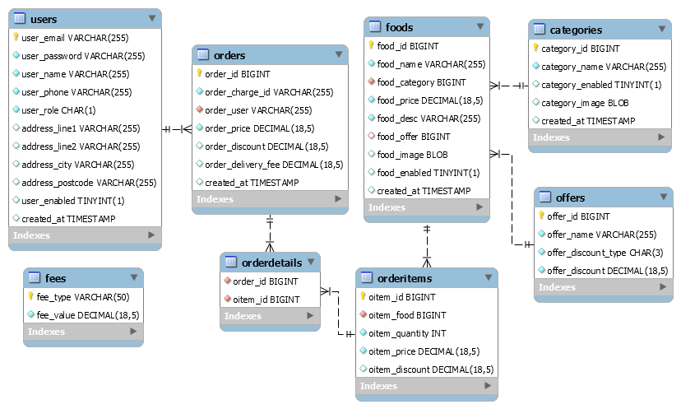

*Figure 1 Foodbox Database ER Diagram*

# **Backend REST APIs Application**

The REST APIs application is developed with layered architecture approach via Spring Boot framework:

* Spring boot application setup database connection according to the configuration in application.properties.
* Data access layer applies Spring data JPA approach to access and manipulate data of MySQL database tables as requested by service layer. Exception is thrown to service layer if failed to execute database queries.
* Service layer has Authentication, Category, Fee, Food, Offer, Order, Stripe and User services. The services generally validate data request received by controller and forward the request to data access layer if validation succeeded. It returns data or successful status to controller if data access layer able to complete the database queries execution. Otherwise, exception is thrown to presentation layer.
* Presentation layer consists of:
  + Controllers – AuthenticationController, CategoryController, ChargeController, FeeController, FoodController, OfferController, OrderController or UserController accepts and processes REST API requests from front-end web pages.
  + Exception Handler – FoodBoxDaoException thrown from data access layer and FoodBoxServiceException thrown from service layer to presentation layer are caught and handled by GlobalExceptionHandler. In addition, the exception handler also handles DTO validation exception. It wraps error message into FoodBoxError object and return error response to front-end side.
* Data transfer objects (DTO) are used by the controllers, service and data access layers to carry model data from data access layer to presentation layer and vice versa. DTO declares model/interface attributes with validation rule.
* Entities are domain objects used mainly by DAO and JPA repositories to query database.
* Mappers map data of entity to DTO and vice versa.

# **Frontend Web Application**

The web application is developed with Angular framework:

* Components are mainly divided into two parts:
  + Admin
  + User
* Footer component is commonly shared between Admin and User components.
* Credit component display link of graphics source URLs for creative credit purpose.
* There are three types of services:
  + API services: AuthenticationService, CategoryService, ChargeService, FeeService, FoodService, OfferService, OrderService and UserService
    - Authentication service: Manage logged-in admin or user details in browser session storage
  + Configuration service: Load environment variable from environment.ts or environment.prod.ts. The API services load API URL environment variable from configuration service.
  + Data service: Provide data sharing service between components. It observes data changes and publishes data to subscribers upon detecting data changed action. The data shared among components are:
    - Categories
    - Offers
    - Login user
    - Current admin food page info
    - Current user food page info
    - User cart
* Cart service does not fall under the aforementioned types of services. It manages cart details in browser session storage.
* Interfaces or models wrap API request or response data, and data shared between components.
* Authentication guard: Authenticate admin or user login session.

# **Automation Testing**

## Backend

Pre-requisite: Database needs to be ready prior to the testing.

Integration tests are written with @SpringBootTest annotation to validate different layers of the REST API Spring Boot application, from Controller, to Service, to Data Persistence Layer.

The integration tests need to start the Spring application context container to execute the test cases. Spring MockMvc is applied to simulate the handling of incoming HTTP requests and hands it off to the Controllers. In this case, end-to-end scenarios would be executed, tested and verified.

## **Frontend**

Pre-requisite: Database, Backend and Frontend application needs to be ready prior to the testing.

Selenium and TestNG framework are applied to write unit tests to test and verify the user interfaces of the Angular web application run across Chrome and Firefox browsers.

# Git Repository, Branching and Tagging

## **Git Repository**

The GitHub HTTPS repository link is

<https://github.com/simplilearn-sonali>

The command below clones the Git repository from the console terminal.

|  |
| --- |
| $ git clone <https://github.com/simplilearn-sonali> |

The following are the steps to setup, compile and run the backend REST APIs application and frontend web application in localhost development environment.

The API service can be accessed by the frontend web application via API root URL <http://localhost:7070/api>.

The user portal can be accessed at <http://localhost:4200>. The admin portal can be accessed at <http://localhost:4200/admin>.

# **DevOps**

The CI/CD pipeline is implemented using Jenkins job. It is built for the continuous deployment of the Foodbox applications and hosting the applications on AWS EC2 instance. It is also built to compile and validate the built artefact with automation testing continuously.

For this project, two Jenkins jobs are created for separate Git branches.

* FSD-CPS-DEV - Run based on develop branch with simplilearn_fsd_projects\Capstone\foodBox\Jenkinsfile.
* FSD-CPS-STAGING – Run based on master branch with simplilearn_fsd_projects\Capstone\foodBox\Jenkinsfile-staging.

## **CI/CD Infrastructure**

Before running Jenkins jobs, initial setup of AWS EC2 instance and Jenkins server is required. Jenkins server and the jobs need to be configured with items below:

* A GitHub account and a Git repository branch for checking out source codes
* A Docker Hub account and a docker repository for publishing docker images
* Publish over SSH to AWS EC2 instance

## **CI/CD Workflow**

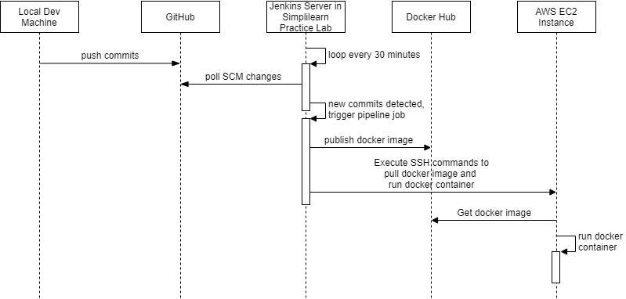

*CI/CD Workflow*

# **Sprint Planning**

The project is delivered within four sprints (around one-week per sprint), with every sprint delivering a minimal viable product. It is estimated to have about 20 hours per sprint. The project start date is 03-October-2021 and finished by 22-October-2021.

*Table 1 Sprint User Stories*

|  |  |  |
| --- | --- | --- |
| **No.** | **User Stories** | **Estimated Hours** |
| **Sprint 1** | | |
| 1 | As a developer, I want to setup MySQL connection and Spring Boot enabled Eclipse Maven project in my local machine so that I can start to develop REST APIs application. | 0.5 |
| 2 | As a developer, I want to create MySQL schema of Foodbox database and populate sample data so that I can start to develop data query implementation for the REST APIs. | 0.5 |
| 3 | As a developer, I want to create a ‘develop’ branch so that the incremental feature development can be tested in ‘develop’ branch whilst the master branch will be used for end-of-sprint release and staging. | 0.5 |
| 4 | As an administrator, I want to log-in to admin portal so that my browser session storage is saved, and I am allowed to manipulate master data and view reports. | 0.5 |
| 5 | As an administrator, I want to have a navigation bar in admin portal so that I can navigate to categories, foods, offers, and reports pages, and logout. | 1 |
| 6 | As an administrator, I want to log-out from admin portal so that my browser session storage will be removed. | 0.5 |
| 7 | As an administrator, I want to view a list of food categories in a table so that I can proceed to update, delete, or enable/disable the available categories. | 1 |
| 8 | As an administrator, I want to add a food category so that the food category will be displayed in user portal. | 1 |
| 9 | As an administrator, I want to update food category so that the food category data change will be reflected in user portal. | 1 |
| 10 | As an administrator, I want to delete a food category so that the removed food category will not be displayed in user portal. | 1 |
| 11 | As an administrator, I want to enable/disable a food category so that the enabled/disabled food category will/will not be displayed in user portal. | 1 |
| 12 | As an administrator, I want to add or update category image so that the category image can be downloaded and displayed in user portal. | 1 |
| 13 | As a guest/user, I want to have a navigation bar in user portal so that I can navigate to food search result page and cart pages, and logout. | 1 |
| 14 | As a guest/user, I want to view the list of food cuisines/categories with image and name when landed user portal so that I can navigate to foods catalog page. | 1 |
| 15 | As a guest, I want to sign up as user so that I can log-in to user portal. | 1 |
| 16 | As a user, I want to log-in to user portal so that my username will be displayed at top-right corner of the navigation bar. | 0.5 |
| 17 | As a user, I want to log-out from user portal so that my username will not be displayed at top-right corner of the navigation bar. | 0.5 |
| 18 | As a tester, I want to write unit/integration tests so that I can validate the REST controllers, services and data persistence layer for the authentication and food categories. | 1 |
| 19 | As a tester, I want to write selenium tests so that I can validate the user interfaces of authentication and food categories for both user and admin portal. | 2 |
| 20 | As a developer, I want to create a new git tag from master branch so that I can release applications for this sprint. | 0.5 |
| 21 | As a DevOps engineer, I want to build a Jenkins CI/CD pipeline so that to automate application builds and tests with docker containers. | 3 |
| **Sprint 2** | | |
| 1 | As an administrator, I want to view a list of offers in a table so that I can proceed to update or delete the available offers. | 1 |
| 2 | As an administrator, I want to add an offer so that the offer will be displayed in user portal. | 1 |
| 3 | As an administrator, I want to update an offer so that the offer data change will be reflected in user portal. | 1 |
| 4 | As an administrator, I want to delete an offer so that the removed offer will not be displayed in user portal. | 1 |
| 5 | As an administrator, I want to view a list of my food items in a table so that I can proceed to update, delete, or enable/disable the available food items. | 1 |
| 6 | As an administrator, I want to view a list of food items in a table by pagination, so that to reduce data loading time when food item number getting bigger. | 2 |
| 7 | As an administrator, I want to sort the list of food items in a table, so that the food items can be sorted by food name, category, price, offer, created date, enabled/disabled status in ascending order. | 1 |
| 8 | As an administrator, I want to add a food item so that the food item details will be displayed in user portal. | 1 |
| 9 | As an administrator, I want to update a food item so that the food item data change will be reflected in user portal. | 1 |
| 10 | As an administrator, I want to delete a food item so that the removed food item will not be displayed in user portal. | 1 |
| 11 | As an administrator, I want to enable/disable a food item so that the enabled/disabled food item will/will not be displayed in user portal. | 1 |
| 12 | As an administrator, I want to add or update food image so that the food image can be downloaded and displayed in user portal. | 1 |
| 13 | As a guest/user, I want to view the list of food items with image, name price after selecting food cuisine/category so that I can navigate to food details page. | 1 |
| 14 | As a guest/user, I want to view the list of food items in card layout by pagination, so that to reduce data loading time when food item number getting bigger. | 2 |
| 15 | As a guest/user, I want to sort the list of food items so that the food items can be sorted by name, lowest price and highest price. | 1 |
| 16 | As a guest/user, I want to filter the list of food items so that the food items can be filtered by food categories or offers. | 1.5 |
| 17 | As a guest/user, I want to search food with keyword so that the search result of food items will be displayed in cards layout and allow navigation to food details page. | 1 |
| 18 | As a developer, I want to create a new git tag from master branch so that I can release applications for this sprint. | 0.5 |
| **Sprint 3** | | |
| 1 | As a guest/user, I want to navigate to the food details page so that I can view the food image, name, category, description, price and offer, and add food item to cart. The cart item number will also be refreshed and displayed at navigation bar after adding food item to cart. | 1 |
| 2 | As a guest/user, I want to navigate to the food cart page so that I can view a list of cart items and the summary of price to paid. | 1 |
| 3 | As a guest/user, I want to remove the cart item from the cart page so that the cart item will not be displayed in cart page, the summary of price to paid and the cart item number at the navigation bar will be changed accordingly. | 1 |
| 4 | As a guest/user, I want to increase or reduce the number of cart items in cart page so that the summary of price to paid and the cart item number at the navigation bar will be changed accordingly. | 2 |
| 5 | As a guest, I want to be forced to sign-in as user so that I can continue to check out and make payment after confirming the cart items. | 0.5 |
| 6 | As a developer, I want to investigate about Stripe payment gateway so that I can integrate the service to both backend and frontend application. | 2 |
| 7 | As a user, I want to check out and make payment so that I can confirm my order. | 2.5 |
| 8 | As a user, I want to view my order details after performing checkout and payment so that I can confirm my order, and my food will be delivered. | 1 |
| 9 | As a user, I want to view my order history so that I can review my previous orders. | 1 |
| 10 | As an administrator, I want to view and filter the list of order reports between two dates so that I can review the orders processed by the system between two dates. | 2 |
| 11 | As an administrator, I want to view and filter the list of user reports between two dates so that I can review the users signed-up to the system between two dates. | 1 |
| 12 | As a DevOps engineer, I want to create docker repository for both backend and frontend applications so that I can publish docker images of backend and frontend applications and pulled and deployed the docker images at AWS EC2 instance. | 0.5 |
| 13 | As a DevOps engineer, I want to add stages of publishing docker images and deploying applications to AWS EC2 instance to Jenkins CI/CD pipeline so that the application deployment can be automated. | 4 |
| 14 | As a developer, I want to create a new git tag from master branch so that I can release applications for this sprint. | 0.5 |
| **Sprint 4** | | |
| 1 | As a tester, I want to add more unit/integration tests so that I can validate the available REST controllers, services, and data persistence layer. | 5 |
| 2 | As a tester, I want to add more selenium tests so that I can validate the user interfaces of the available web pages for both user and admin portal. | 5 |
| 3 | As a developer, I want to fix bugs found by tester so that to ensure minimum application defects before ending the project. | 4.5 |
| 4 | As a developer, I want to create a new git tag from master branch so that I can release applications for this sprint. | 0.5 |
| 5 | As a developer, I want to write specification document so that to demonstrate the application features and capabilities to Foodbox management team. | 5 |

# **Conclusion**

The REST APIs application can be further enhanced:

* To support web security for authentication, authorization, and access of frontend API requests.
* To support HTTPs connection
* To add logging for backend system tracing

The web application can be further enhanced:

* To add authorization details to HTTP header in API service methods.
* To add support of descending sort of food list in admin portal by food name, category, price, offer, created date and enabled/disabled status.
* To make currency of food price and payment price configurable
* To load and display food item cards upon scrolling down to the page

**GitHub Repository Link:**

<https://github.com/simplilearn-sonali>

**Automation testing:**

* The available unit tests, integration tests and selenium tests are not sufficient to fulfill 100% test coverage due to time constraint and time management problem.